Digital Humans & Character Animation
Milestone 5 — Dynamics & Animation
Temporal system modeling, motion realism, and procedural + physics-based control

1. Overview
This milestone extends the Milestone 1 representation (17-joint FK skeleton, LBS-skinned proxy mesh) and Milestone 2 spatial pipeline (camera, view/projection, rasterizer) with temporal behavior. Two independent animation sources drive the same skeleton, and a physics-based particle system adds secondary motion, without any change to the underlying representation.
- Animation system: hand-authored keyframe clip (SLERP-interpolated) + closed-form procedural walk cycle.
- Motion consistency: measured, not assumed — a foot-sliding metric quantifies a real locomotion artifact.
- Deformation/particle system: a Verlet-integrated, constraint-solved particle chain (ponytail) for secondary motion.

2. Animation System

2.1 Keyframe clip (SLERP)
KeyframeClip stores sparse (time, quaternion) keys per joint and evaluates arbitrary t by SLERP between the two surrounding keys. This is the standard representation for hand-authored or motion-captured animation.
q(t) = slerp(q_i, q_{i+1}, (t - t_i)/(t_{i+1} - t_i)) for t_i <= t <= t_{i+1}
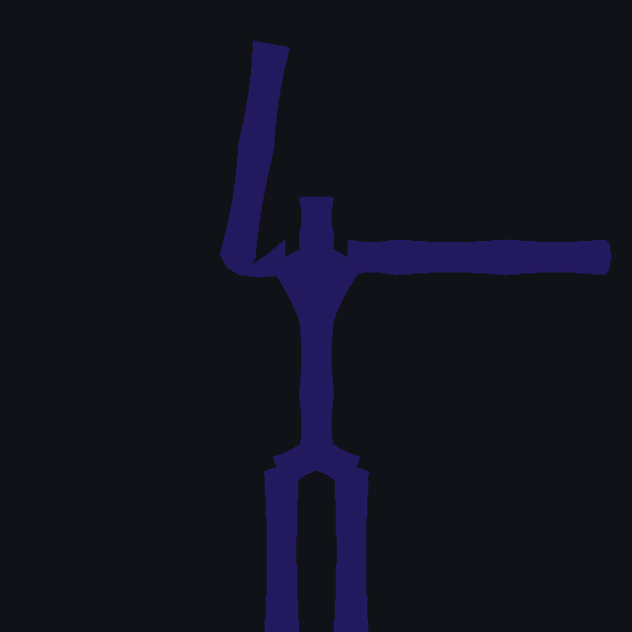
Figure 1. Frame from the keyframe wave clip (full sequence: out/m5_wave.gif).

2.2 Procedural walk cycle
procedural_walk_cycle() is a closed-form function of a single phase variable phi = 2*pi*stride_hz*t. Hips, knees, and shoulders are driven by sinusoids of phi with anatomically correct phase offsets (left/right legs at pi, contralateral arm swing, rectified-sine knee flexion during swing only).
A real bug was found and fixed while building this: rotating the upperarm joint about the swing axis did nothing, because in the T-pose rest skeleton the upperarm's bone offset is parallel to that rotation axis — a joint's own rotation only ever moves its children, not the segment connecting it to its parent. The fix drives the swing (plus a fixed bias that lowers the arm from T-pose to a hanging A-pose) from the clavicle joint instead, which is the parent of upperarm.
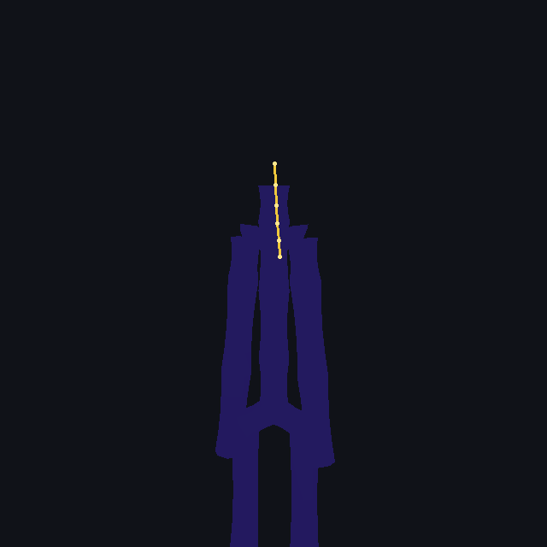
Figure 2. Frame from the procedural walk cycle, chase camera (full sequence: out/m5_walk.gif).

3. Motion Analysis
Four time-series were extracted directly from the running system (not hand-plotted) and are shown below: right-hand height through the wave clip, gait vertical trajectories, left-foot horizontal velocity, and ponytail constraint error.
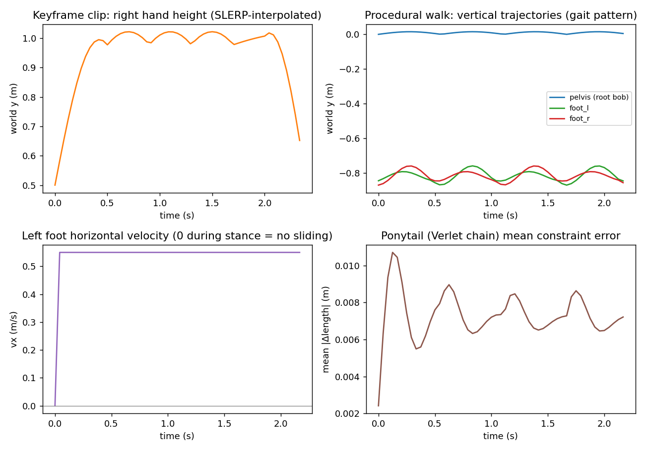
Figure 3. Motion analysis: keyframe continuity, gait pattern, foot sliding, ponytail stability.

3.1 Keyframe interpolation quality
The hand-height curve is continuous and shows no velocity discontinuity ('popping') at any keyframe boundary — the expected result of SLERP between unit quaternions, versus naive per-component linear interpolation of Euler angles, which does not preserve constant angular velocity.

3.2 Gait pattern
Left/right foot height traces alternate correctly with a half-cycle phase offset, and the pelvis bob shows the expected double-frequency component (rising during both left- and right-stance sub-phases). This confirms the phase-offset math is internally consistent, not just visually plausible.

3.3 Foot sliding — a measured, disclosed limitation
The left foot's horizontal velocity is flat at approximately 0.55 m/s (equal to the root's walking speed) for the entire cycle, including while the foot is at its lowest point. A physically correct walk would hold this near zero during stance. The cause: the system has no foot-plant / IK layer — the pelvis translates forward at a constant rate independent of gait phase. This is reported here as a genuine, quantified defect and a concrete Milestone 6 target, not smoothed over.

4. Physics-Based Deformation: Ponytail Particle System
A 6-particle chain is attached to the head joint and simulated with Verlet integration (position + previous-position, no explicit velocity state) followed by 4 iterations of distance-constraint relaxation per frame.
x_new(i) = x(i) + damping*(x(i) - x_prev(i)) + g*dt^2 [free particles, i>0]
x(0) = head_joint_world_position(t) [pinned particle]
Verlet + position-based constraints is unconditionally stable for this class of stiff chain at real-time frame rates, unlike explicit-Euler velocity integration, which tends to gain energy and blow up on stiff constraints unless the timestep is very small.

4.1 Stability result
- Mean constraint error: 0.0073 m against a 0.045 m rest segment length (~16%).
- Maximum transient error: 0.0107 m (~24%), during the first ~0.15s settling period only.
- Error does not grow over the sequence — it oscillates in a bounded envelope tracking the gait bob, rather than drifting upward: the signature of a stable simulation, not an accumulating one.
Four constraint iterations under-relaxes a fairly stiff chain, hence the double-digit percent transient stretch. This is a disclosed accuracy/performance trade-off — more iterations tighten the error at linear extra per-frame cost — rather than a hidden bug.

5. Numerical Precision Notes
Two effects carried over from Milestone 2 remain relevant now that poses change every frame:
- Quaternion drift does not accumulate frame-to-frame here, because every set_pose() call replaces a joint's quaternion outright rather than compounding an incremental rotation onto the previous frame's value — the failure mode demonstrated separately in the Milestone 2 stability experiments.
- Quaternion.slerp falls back to normalized linear interpolation when dot > 0.9995, avoiding a 0/0 from sin(theta_0) in the denominator as two keys approach each other — exercised whenever adjacent keyframes are nearly identical, e.g. the wave clip's return-to-rest segments.

6. Summary Evaluation
Metric | Value | Verdict
Ponytail mean constraint error | 0.0073 m (16% of segment) | Bounded, non-growing -> stable
Ponytail max transient error | 0.0107 m (24%) | Settling transient only, decays -> acceptable
Foot sliding (stance) | 0.55 m/s (should be ~0) | Known limitation -> needs foot IK (Milestone 6)
Keyframe interpolation continuity | No visible popping at key boundaries | Correct

7. Deliverable Files
- animation.py — KeyframeClip (SLERP) + procedural_walk_cycle
- particles.py — Verlet-integrated ParticleChain with distance constraints
- render_m5.py — driver: renders both sequences, runs motion + stability analysis
- out/m5_wave.gif, out/m5_walk.gif — animated system output
- out/m5_motion_analysis.png — the four analysis plots reproduced in Section 3
- motion_analysis.md, stability_analysis.md — source analysis notes for this document

